ASSIGNMENT -9

Querying Multiple Tables at Once.

Q1) write a query that list each order number followed by the name of customer who made the order.

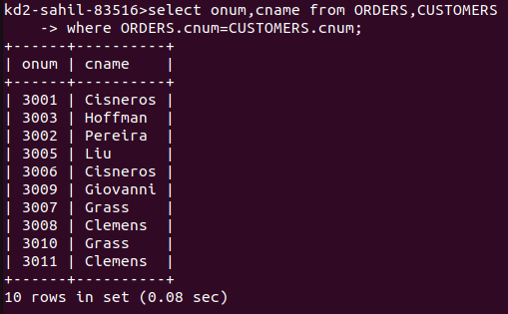

Q2) write a query that gives the names of both the salesperson and the customer for each order along with the order number.

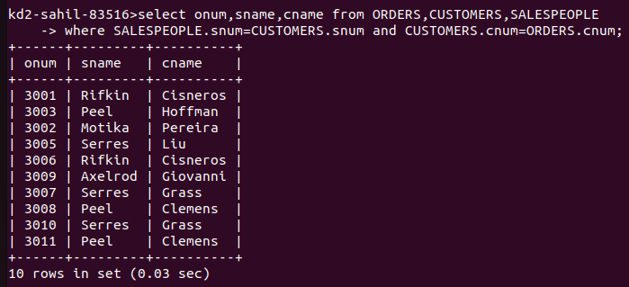

Q3) write a query that produces all customers serviced by salespeople with a commission about 12%. Output the customer’s name, the salesperson’s name, and the salesperson’s rate of commission.

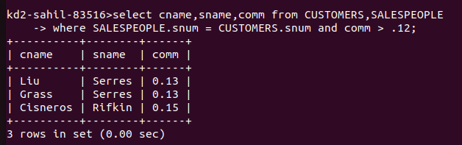

Q4) write a query that calculates the amount of the salesperson’s commission on each order by a customer with a rating above 100.

